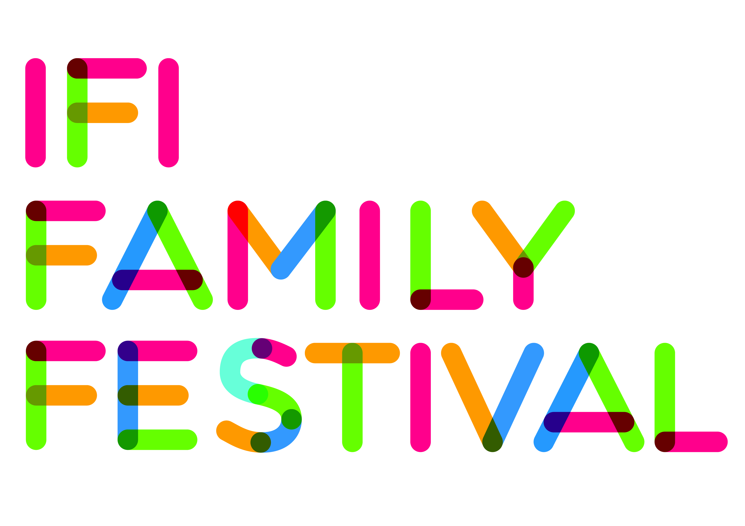

Autism-Friendly Screening:

Das Pferd auf dem Balkon/A Horse on the Balcony

We will be offering an Autism-Friendly Screening of A Horse on the Balcony on:
July 13th, 2013 at 1pm.

What is an Autism-Friendly Screening?

In an Autism-Friendly cinema screening:

- The sound is reduced
- The lighting is set at a higher level
- There is no advertising or trailers
- You are free to bring snacks
- Subtitles will be read aloud
- You will be able to move around the cinema if you like* **

*Guests are reminded not to run inside the cinema.
** Children are to be supervised at all times.

A Horse on the Balcony is the story of Mika, a ten-year-old boy with Asperger’s Syndrome and a gift for mathematics. One night, he sees a horse on the balcony of the apartment opposite. He develops a close bond with the former racehorse and is very angry to find out that the owner, Sascha, who is a former maths teacher plans to sell the horse to repay money he owes to violent men. Mika and his friend Dana figure out an ingenious plan to save their four-legged friend.

AUSTRIA • 2012 • 90 MIN • ENGLISH SUBTITLES • DRAMA • DIRECTOR: HUSEYIN TABAK

This Autism-Friendly screening is in association with Irish Autism Action.
Actor Laurence Kinlan (Love/Hate, The Guard), Friend of Irish Autism Action, will present this screening. See www.ifi.ie/familyfest for more details.

Please note that carer’s will not be charged admission for this screening but to avail of this, bookings must be made in person at the Box Office or over the phone 01 – 679 3477. Maximum of 1 carer per person.

