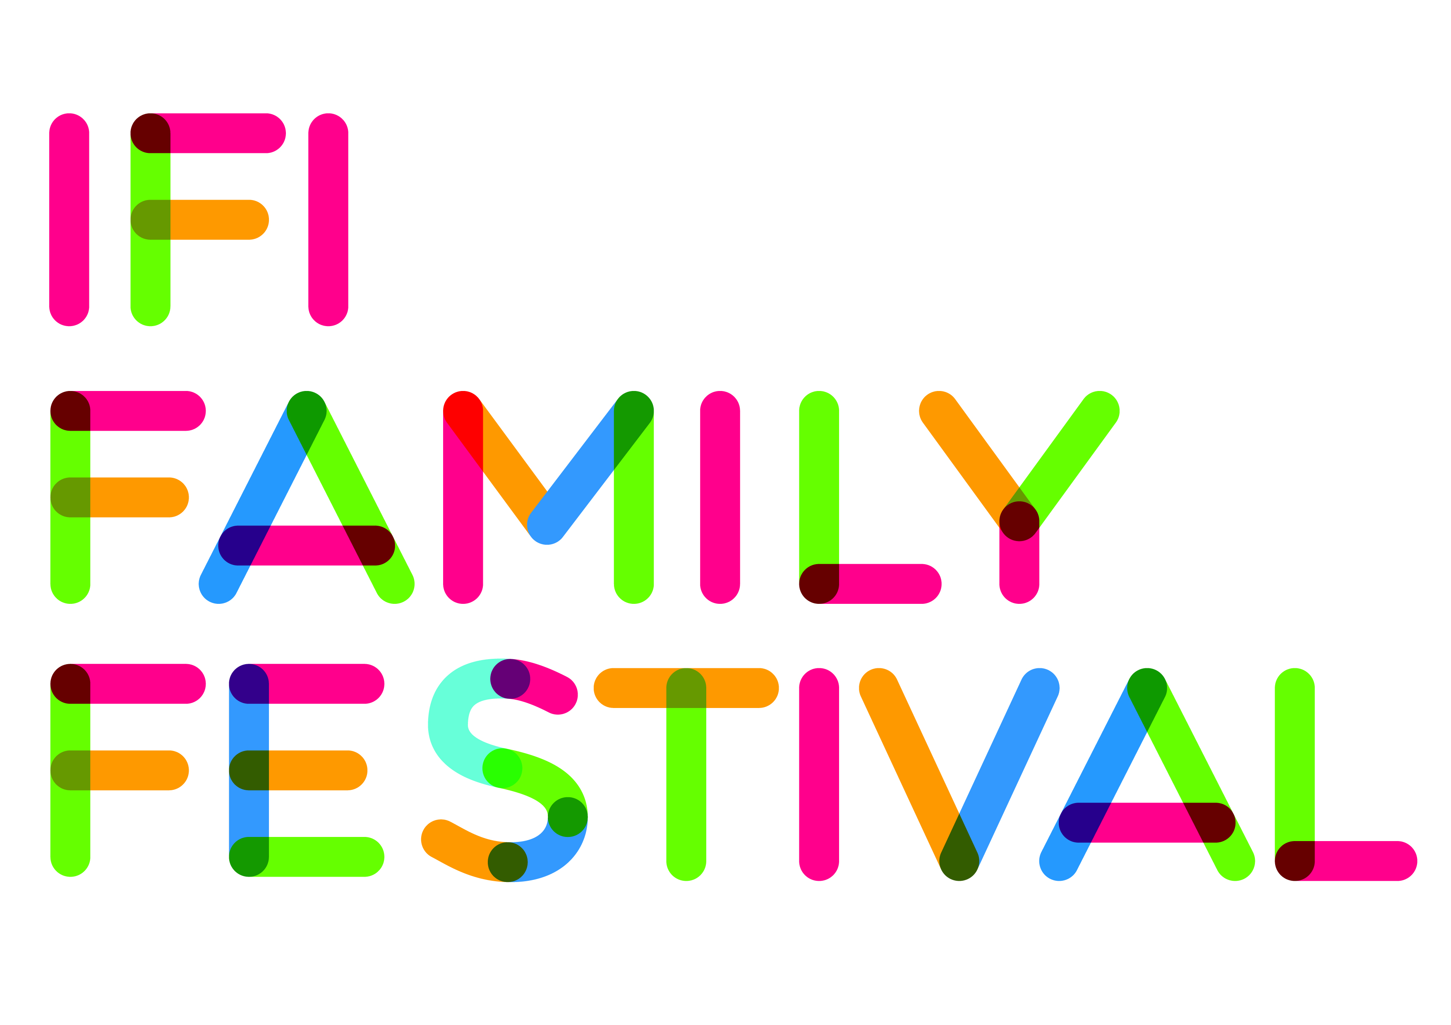
Chaperoned Screening
To facilitate parents/guardians who would like to bring children of different ages to IFI Family Festival, we have a chaperoned screening of Short Tales 2 (Age 8+) on Sunday, July 14 at 11am. You can then bring younger children to Poppety in the Fall (Age 6+). Both programmes run for approximately 1 hour.
An IFI Family Festival Chaperone will sit with the unaccompanied children during Short Tales 2. (ratio 1: 8, in accordance with our Child Protection Guidelines see www.ifi.ie/learn/childprotection).
Please note: You must have a child attending Poppety in the Fall in order to avail of the Chaperone Screening for Short Tales.
Tickets are required for both screenings.

