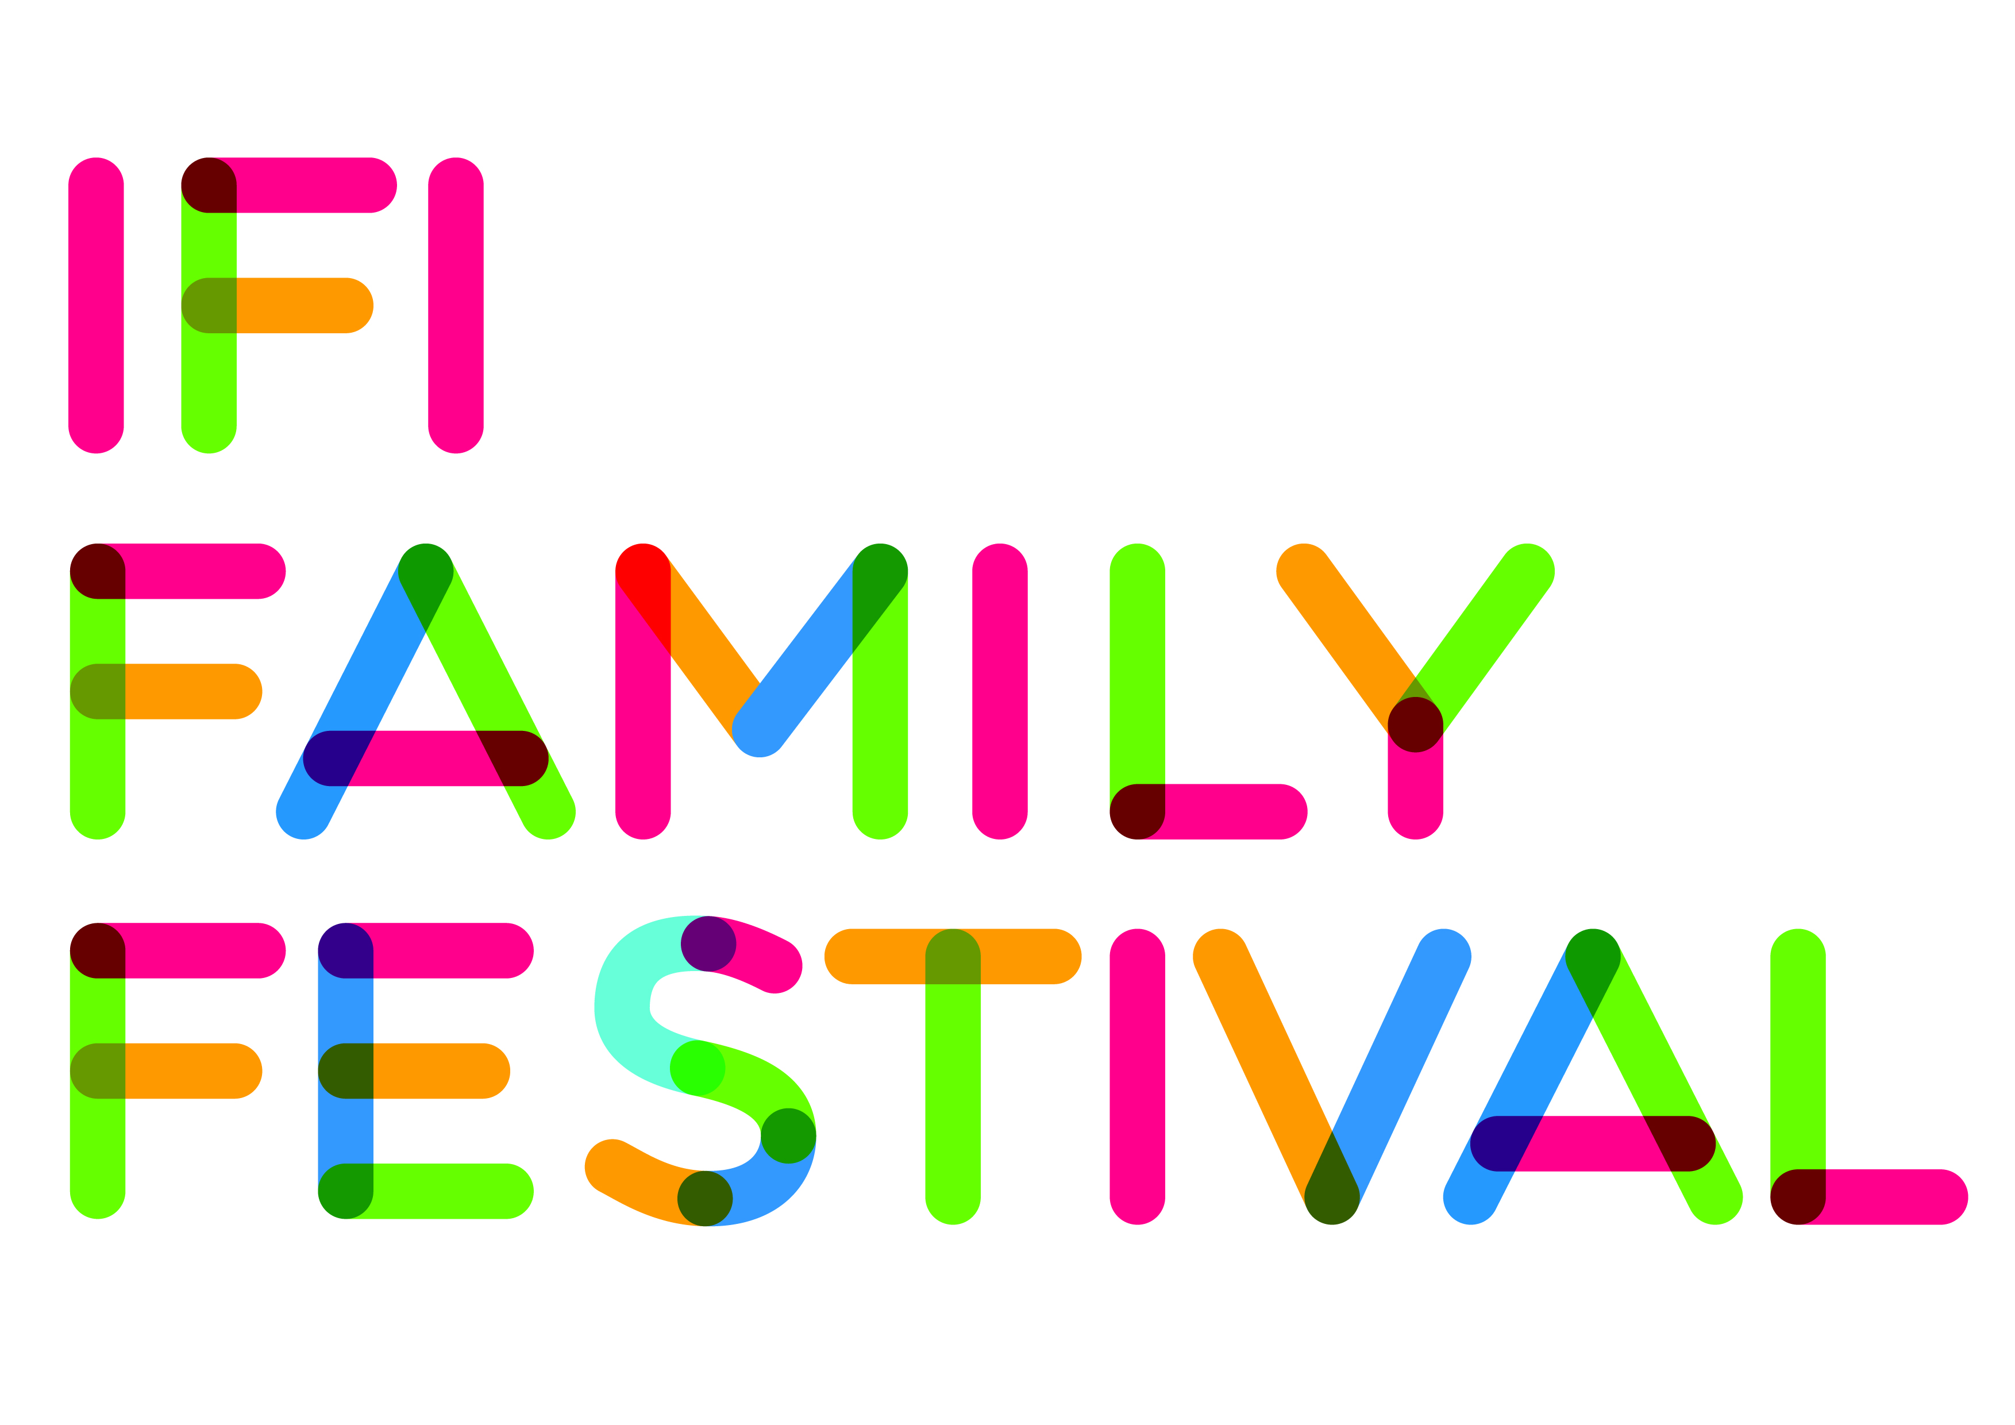

SR: Subtitles Reader

Are you new to subtitled films?
Don’t worry! Subtitles are read aloud by an experienced reader during our Family Festival and monthly Family screenings at IFI.

Why do we have a Subtitles Reader?
Many young viewers are not used to subtitles or find them hard to follow. Yet there are so many subtitled films from around the world that we would like our young audiences to see. For the IFI Family Festival, we follow other international children’s’ film festivals and use a Subtitles Reader so that there is no barrier to enjoying the film.

What does this sound like?
With the sound of the film turned down, the subtitles are read aloud so that all children are able to enjoy the films. Please note, this is not a dramatic performance.

Can I still hear the soundtrack?
Yes, you can still hear the original soundtrack of the film. That includes music and sound effects.

Can I hear the original language?
For those who may be able to speak the original language of the film, we do our best to ensure that the original language can be heard. However, depending on the film’s soundtrack, it is not always possible to achieve this fine balance.

Who is this for?
For films targeted at audiences up to 10 years of age.

For films targeted at audiences up to age 10

